Moai of Easter Island

Located in the southeastern Pacific Ocean, Easter Island, also known as Rapa Nui, is famous for immense, carved stone statues called moai. A completed moai is made of three parts: a large yellow body, a red hat or topknot (called pukao), and white inset eyes with a coral iris.
Approximately 1,000 of these sculptures, shaped with humanoid faces and torsos, were created, most of which range between 6 and 33 feet tall and weighing several tons. Carving of the moai is thought to have begun shortly after people arrived on the island ca. 1200, and ended ca. 1650. Take a look at some of what science has learned about the Easter Island moai, how they were made, and the methods used to move them into place.
Decorating the Moai

Probably the least known aspect of the Easter Island moai is that some of them were decorated with elaborate carvings, and quite likely many more were than we know about today. Similar petroglyphs are known from carvings in the volcanic bedrock around Rapa Nui, but exposure of the volcanic tuff on the statues has weathered the surfaces and perhaps destroying many carvings.
Photogrammetry modeling of an example in the British Museum—which was carved out of hard grey flow lava rather than the soft volcanic tuff—reveal detailed carvings on the statue's back and shoulders.
How to Move a Moai

Between 1200 and 1550, about 500 moai were moved out of the Rano Raraku quarry by the islanders for distances of up to 11 miles, a truly massive undertaking. Theories about moving the moai have been addressed by several scholars over the decades of research on Easter Island.
Since the 1950s, various experiments moving moai replicas have been attempted by methods like using wooden sleds to drag them around. Some scholars argued that using palm trees for this process deforested the island, however, that theory has been debunked for many reasons.
The most recent and successful moai moving experiment, in 2013, involved a team of archaeologists wielding ropes to rock a replica statue down the road as it stood erect. Such a method echoes what the oral traditions on Rapa Nui tell us; local legends say the moai walked from the quarry.
Crafting a Group

In some cases, the Easter Island moai were placed in arranged groups on ahu platforms painstakingly constructed from small, water-rolled beach boulders (called poro) and walls of dressed flow lava stone. In front of some of the platforms are ramps and pavements which may have been built to facilitate the placement of the statues, and then veneered once the statue was in place.
Poro are found only on beaches, and aside from the statues, their primary use was as pavement for sea slipways or boat-shaped houses. It's possible that using a combination of beach and inland resources to construct the moai had great cultural significance to the islanders.

Resources and Further Reading
- Awes, Maria, and Andy Awes. “Mystery of Easter Island.” NOVA, season 39, episode 3, PBS, 7 Nov. 2012.
- Hamilton, Sue. “Rapa Nui (Easter Island)’s Stone Worlds.” Archaeology International, vol. 16, 24 Oct. 2013, pp. 96-109.
- Hamilton, Sue, et al. “Say It with Stone: Constructing with Stones on Easter Island.” World Archaeology, vol. 43, no. 2, 14 July 2011, pp. 167-190.
- Hunt, Terry L., and Carl P. Lipo. The Statues That Walked: Unraveling the Mystery of Easter Island. Simon and Schuster, 2011.
- Lipo, Carl P., et al. “The ‘Walking’ Megalithic Statues (Moai) of Easter Island.” Journal of Archaeological Science, vol. 40, no. 6, June 2013, pp. 2859-2866.
- Miles, James, et al. “New Applications of Photogrammetry and Reflectance Transformation Imaging to an Easter Island Statue.” Antiquity, vol. 88, no. 340, 1 June 2014, pp. 596-605.
- Miles, James. “The Voice of Easter Island in the British Museum.” Archaeological Computing Research Group, University of Southampton, 14 Nov. 2013.
- Richards, Colin, et al. “Road My Body Goes: Re-Creating Ancestors from Stone at the Greatmoaiquarry of Rano Raraku, Rapa Nui (Easter Island).” World Archaeology, vol. 43, no. 2, 14 July 2011, pp. 191-210.
- Thomas, Mike Seager. “Stone Use and Avoidance on Easter Island: Red Scoria from the Topknot Quarry at Puna Pau and Other Sources.” Archaeology in Oceania, vol. 49, no. 2, 10 Apr. 2014, pp. 95-109.

8 INTERESTING FACTS ABOUT EASTER ISLAND
• Completely isolated in the middle of the Pacific Ocean, the island is 3,700km west of the coast of continental Chile.
• The cultural and archaeological treasures of Easter Island were the first of any Pacific island nation to be registered by UNESCO on its World Heritage List.
• The name Easter Island was given by Jacob Roggeveen, the first recorded European visitor to the island on 5 April 1722, which so happened to be Easter Sunday.
• There are nearly 900 Moai on Easter Island, in various stages of construction.
• The average size of a Moai statue is 13 feet tall and 14 tons.
• Built to honour a chieftain or important people the natives believed the spirit of the person would forever watch over the tribe and bring good fortune. This is why the statues are called Moai: the word comes from Rapa Nui (the Polynesian language of Easter Island) and means “so that he can exist”.
• None of the Moai statues were standing when scientists first arrived, those upright today have been re-erected.
• Although commonly known as the ‘Easter Island heads’ this is a misconception as it was discovered in 2012 that all of the heads have full bodies which have become submerged.

Easter Island
Rapa Nui
Isla de Pascua
Special Territory, Province and Commune
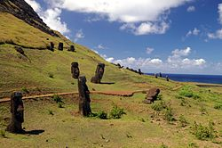

Flag
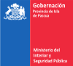
Seal
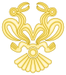
Coat of arms
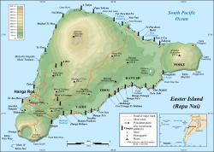
Easter Island map showing Terevaka, Poike, Rano Kau, Motu Nui, Orongo, and Mataveri; major ahus are marked with moai
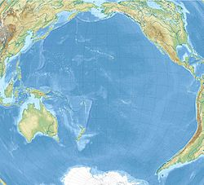
Easter Island
Easter Island in the Pacific Ocean
Coordinates: 27°7′S 109°22′WCoordinates: 27°7′S 109°22′W
Country | Chile
Region | Valparaíso
Province | Isla de Pascua
Commune | Isla de Pascua
Seat | Hanga Roa
Government
• Type | Municipality
• Body | Municipal council
• Provincial Governor | Laura Alarcón Rapu (IND)
• Alcalde | Pedro Edmunds Paoa (PRO)
Area
^{[2]}
• Total | 163.6 km² (63.2 sq mi)
Highest elevation | 507 m (1,663 ft)
Lowest elevation | 0 m (0 ft)
Population
(2017 census)
• Total | 7,750^{[1]}
Time zone | UTC−6 (CLT)
• Summer (DST) | UTC−5 (CLST)
Country Code | +56
Currency | Peso (CLP)
Language | Spanish, Rapa Nui
Driving side | right
Website | http://www.rapanui.net
NGA UFI=-905269

Rapa Nui National Park
UNESCO World Heritage Site

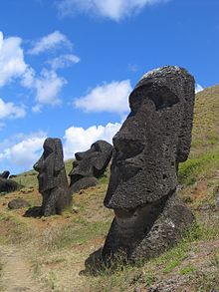
Moai at Rano Raraku, Easter Island
Criteria | Cultural: i, iii, v
Reference | 715
Inscription | 1995 (19th Session)
Area | 6,666 ha

